
Azure Site Recovery (ASR) Deployment

Presented to:
CLIENT NAME
2/9/2021

Cognizant Microsoft Business Group
20 North Wacker Drive #530
Chicago, IL 60606

Notice of Confidentiality ©2021 Cognizant Microsoft Business Group All rights reserved.

IS SUBJECT TO THE TERMS OF THE COGNIZANT MICROSOFT BUSINESS GROUP NON-DISCLOSURE AGREEMENT. NEITHER THIS DOCUMENT NOR ITS CONTENTS MAY BE REVEALED OR DISCLOSED TO UNAUTHORIZED PERSONS OR SENT OUTSIDE THE AFOREMENTIONED COMPANY WITHOUT PRIOR PERMISSION FROM COGNIZANT MICROSOFT BUSINESS GROUP.
Table of Contents
Summary 3
Prerequisite Activities 4
Deployment 4

Summary
This document Is Intended to describe Azure Site Recovery (ASR) architecture and the deployment in the CLIENT NAME environment to support their Azure migration. ASR is the tool that Cognizant Microsoft Business Group uses to migrate machines from on-premises to the Azure Cloud. ASR provides a simple solution to migrate virtual and physical workloads while maintaining app consistency, flexible failovers, and testing in the cloud.
ASR Base Architecture
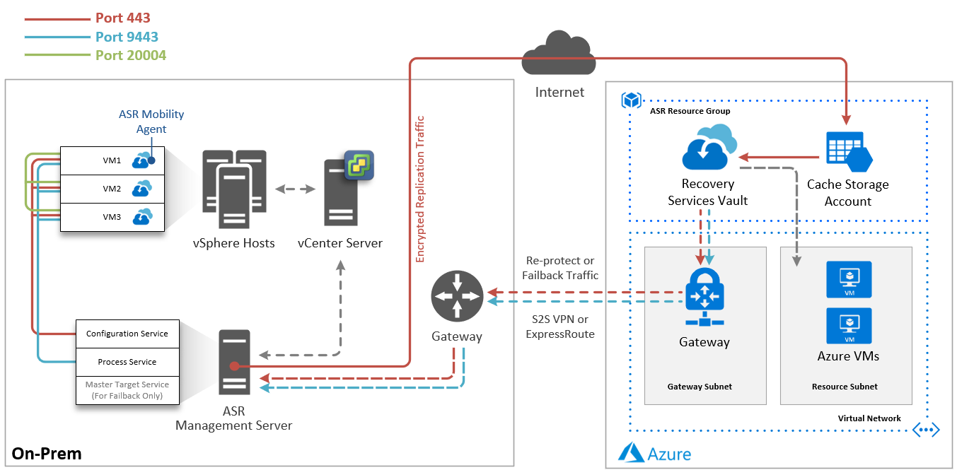

Core Components
Configuration Server – Used for centralized migration management.
Process Server – Used for caching, compression, and encryption. The process server can also be scaled out to allow for additional replication capacity per ASR instance.
Master Target Server – Used only during failback to route replication data to the on-prem configuration and process service. This component is not needed for a migration only project.
Mobility Agent – Light-weight agent installed on the source machines that sends the configuration and replication data to the configuration and process services.
Recovery Services Vault – The Azure cloud target storage entity that houses the source replication data to be used to create the Azure VMs.
Cache Storage Account – An Azure storage account used to cache incoming ASR replication data before being written to the Recovery Services Vault.

Network Communication
HTTPS Port 443 – Used for replication management from the mobility agent on the source VMs to the configuration server. Also used by the configuration and process servers to communicate outbound to Azure to facilitate replication.
HTTPS Port 9443 – Used by the mobility agent on the VMs to send replication data to the process server.
Port 20004 – Used for communication between VMs to facilitate application consistency.

Prerequisite Activities
The following prerequisites need to be completed before the deployment activities are scheduled:
- Details have been provided on source environment – location, vCenter server name/IP
- Details have been provided on which Azure subscriptions are the intended migration targets
- Environment landing area and IP details have been decided for the management servers. For example, what vSphere cluster, storage, and port group the servers will be deployed to, what IP address will be assigned if static, etc.
- The CLIENT NAME Network Team has reviewed the ASR planning guide and allowed the necessary traffic.
- The CLIENT NAME Network Team has assigned and documented an IP space to use for the testing VNET, if applicable.
- The ASR Management Server OVF template should be downloaded and ready to deploy in the source environment(s). You can download the OVF template from http://aka.ms/asrconfigurationserver_cus.

Deployment
The deployment activities should be a collaborative effort between Cognizant Microsoft Business Group and CLIENT NAME IT staff. The following work will be completed remotely. Cognizant Microsoft Business Group will host Microsoft Teams meetings with screensharing to collaboratively complete the activities.
The ASR deployment consists of the following steps:
- Setup supporting Azure components
  - Cognizant Microsoft Business Group will deploy the following in each target subscription via ARM templates:
    - A Resource Group in each subscription to contain all of the ASR migration components. This makes cleanup easier when the migration is complete.
    - A VNET in each subscription to serve as a landing zone for testing migrated servers
    - A NSG in each subscription to isolate the testing VNET
    - A Recovery Services Vault in each subscription configured to log to a Log Analytics Workspace
    - An Automation Account in each subscription for creating migration runbooks
    - Optional: A Log Analytics Workspace dedicated to migration will be created or an existing shared Log Analytics workspace can be used.
- Deployment of four (4) ASR Management Server on-premises – two in the MSP DC, and two in the Milwaukee DC. A preconfigured virtual appliance (OVF template) is available and will be used for this deployment. The base specifications for the appliances are 8 CPU, 16GB RAM, 1.2TB disk space per appliance.
  - CLIENT NAME IT staff will deploy the following:
    - 4 ASR Management Servers in the source vCenter environment(s) from OVF template
    - Configure the servers to proper naming convention and CLIENT NAME standards, configure network connectivity.
    - Update the servers to the latest patch level and add to standard patching process to ensure they are kept up to date.
- Configure the Management Server(s)
  - Cognizant Microsoft Business Group will work with CLIENT NAME IT staff to configure the ASR Management Server(s) and connect them to the source vCenter server and target Recovery Services Vaults.
- Verify and test
  - Cognizant Microsoft Business Group will verify that resources are being discovered in the Recovery Services Vault and replication can be started.
  - Cognizant Microsoft Business Group will work with CLIENT NAME IT staff to remediate any issues that are found.
  - Cognizant Microsoft Business Group will work with CLIENT NAME IT staff to plan migration and failover testing.

Resources to be Deployed
Resource | Name | Deployment Method | Location
ASR Shared Log Analytics Workspace (if not existing) | <resource name to convention> | ARM Template | Azure – <subscription name>
ASR Resource Group |  | ARM Template
ASR Resource Group |  | ARM Template
ASR Resource Group |  | ARM Template
ASR Resource Group |  | ARM Template
ASR Cache Storage Account |  | ARM Template
ASR Cache Storage Account |  | ARM Template
ASR Cache Storage Account |  | ARM Template
ASR Cache Storage Account |  | ARM Template
Migration Automation Account |  | ARM Template
Migration Automation Account |  | ARM Template
Migration Automation Account |  | ARM Template
Migration Automation Account |  | ARM Template
Testing VNET |  | ARM Template | Azure – Customer Experience Prod
Testing VNET |  | ARM Template | Azure – Customer Experience Non-Prod
Testing VNET |  | ARM Template | Azure – Core Retail Prod
Testing VNET |  | ARM Template | Azure – Core Retail Non-Prod
NSG to Isolate Testing VNET |  | ARM Template
NSG to Isolate Testing VNET |  | ARM Template
NSG to Isolate Testing VNET |  | ARM Template
NSG to Isolate Testing VNET |  | ARM Template
ASR Recovery Services Vault |  | ARM Template
ASR Recovery Services Vault |  | ARM Template
ASR Recovery Services Vault |  | ARM Template
ASR Recovery Services Vault |  | ARM Template
ASR Management Server 1 |  | TBD
ASR Management Server 2 |  | TBD
ASR Management Server 3 |  | TBD
ASR Management Server 4 |  | TBD

CLIENT NAME Proposed ASR Architecture
<insert customized diagram below, starters can be found in the delivery templates>

